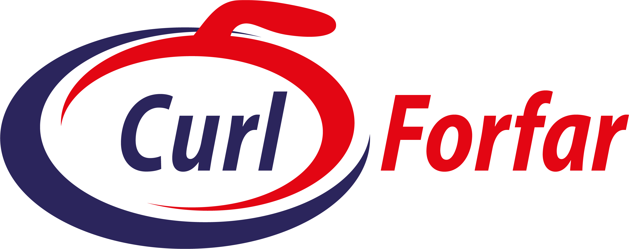

Minutes of Forfar Curling Centre Club Prize Giving & Awards 2024-25 held at Forfar – Thursday 24 April 2025

In Attendance:
There was a good turnout to this evening’s Prize Giving & Awards Night meeting. Approx 66 members were present.

President Neill Smith welcomed everyone to the meeting and explained how the evening programme would progress before handing over to Mike Ferguson.

Brief update on Curling Administrative matters
No curling business to be conducted this evening, but some admin matters to point out:
- Curling Club encouraged to get their ice bookings submitted via the “on-line booking system.” Submitting on-line ensures an audit trail and ensures any errors are minimised.
- All Curling Clubs are encouraged to enter the FCCC leagues and Competitions – either renewing their entries from last year or considering entering for the first time.
- Some new innovations for next season will be leagues for triples, daytime Super Leagues, Mixed Doubles, Pairs.
- 2025 will be the 35th Anniversary of the Forfar Curling facility and it is planned for there to be a 35th Anniversary dinner. This will be on either Saturday September 13th or 20th – the date will be determined by the availability of speakers. FCCC would need a working Group formed to organise and coordinate the evening, so volunteers will be required – ideally one representative from each Club. 20 Clubs taking a table of eight, plus curlers from other Scottish ice rinks would give a sizeable number for a great evening.
- There has been a substantial upgrade to the website and the navigation menus making it much easier to navigate.

Competition Winners and Awards
These were presented and announced by a combination of Neill Smith & Mike Ferguson:
- Prior to the Prizegiving, 3 significant mentions of Forfar curlers were recognised (i) Halley Duff, for being a member of the winning team in the 2025 Scottish Women’s Curling Championship, (ii) Edzell Curling Club for reaching the finals of the 2025 Scottish Rink Championship, (iii) Callie Soutar and her team for winning the Scottish Junior Championships.
- Also announced and introduced, were the new sponsors of the Super League competition for 2025/26. Johnston Oils are to sponsor this competition - £400 to the winning teams of Division 1, Division 2, and the Knockout competitions.
- Super League Division 1 winners – Mike Ferguson’s Team. Relegated – Team Doug Wilson & Team George Christie.
- Super League Division 2 – Caterthun Curling Club Team. Promoted Caterthun CC &Team Martin Gregory.
- Agricar Division 1 – Edzell Curling Club (& cheque for £150). Relegated Aberlemno CC & Pitkerro CC.
- Agricar Division 2 – Fettercairn CC (& cheque for £150). Promoted Fettercairn CC & Dun CC.
- Over 50’s League – Team Mike Ferguson.
- Ladies Friendship League – Letham Grange Ladies CC.
- Swing & Sweep – Edzell CC
- Opening Bonspiel – Dun CC
- The Forfar Open – Team England.
- The Forfar Farmers – Team EJM Engineering
- Charity Bonspiel – Forfar CC
- Rink Championship Qualifiers – Edzell CC
- Callander Trophy – Fothringham CC
- Angus Challenge – Fothringham CC
- Super League Knockout – Team Ferguson
- Over 50’s Knockout – Team White
- Rink Knockout – Edzell CC
- Club Team Points – Letham Grange CC
- Club Team Points (individual) - Keith Gibb, Forfar CC
- Double Rinks – Fothringham CC
- Closing Bonspiel – Forfar CC
- Forfar Ladies Centre Competitions:
  - Breckenridge Trophy – Jackie McQueen, Judith Strachan, Yvonne Wardrope, Mary Hepburn
  - FLC Ladies Open Pairs – Sheilagh MacFarlane & Sandi Buchan
  - FLC Ladies Open – Jill Donald, Liz Furnie, Kirstina Fairweather, Lesley Joiner
  - Henderson Bishop Qualifiers – Lesley Young, Lynda Kemp, Lorna Anderson, Charli Young
  - The Carnegie Challenge – Jane McLaren, Carolyn Nicoll, Lillian Carnegie, Margaret Robertson.

Curling Awards 2024/25:
- There was recognition of the Curling Awards sponsors being:
  - The McGlynn Family, Ron & Kate Caithness, Forfar Young Curlers, Ferguson Oliver Ltd, The White Family, Letham Grange CC, Tannadice Trophies, Forfar Indoor Sports Ltd, & The Smith Family.
- Most Improved Young Curler of the Year: Final nominations were – Ruaridh McCartney, Eilidh Webster, Reuben Hyland (all from Forfar Young Curlers). The Winner was Eilidh Webster.
- Most Improved Curler of the Year: Final Nominations were – Marie Callander (Forfar CC), Barbara Shaw (Fothringham CC), Shaun Smith (Edzell CC). The winner was Barbara Shaw.
- Club of the Year: Final Nominations were – Edzell CC, Dalhousie CC, Fothringham CC. The winner was Dalhousie CC
- FCCC Sportsmanship Award: Final Nominations were – Ewan & Gilli McCulloch (Dun & Edzell CC), Sarah Millar (Pitkerro CC), Alan Walker (Brechin Castle CC). Ewan & Gilli McCulloch were the joint winners
- Senior Curler of the Year: Final Nominations were – Mike Ferguson (Edzell CC), Shaun Smith (Edzell CC), Adrian White (Fothringham CC). The winner was Adrian White.
- Young Curler of the year: Final Nominations were – Jamie Jones, Joe Lindsay, Morag Skea (all Forfar Young Curlers). The winner was Morag Skea.
- Curler of the Year: Final Nominations were – Team Ferguson (Edzell CC), Callie Soutar (Forfar Young Curlers), Mike Ferguson (Edzell CC). the winner was Mike Ferguson.
- The Andy McGlynn Award: The winners of this award was The FIS Team comprising the Bar & Catering Staff, the Ice Team, the Office & Admin Team, and the FIS Management – all of whom contribute to the wonderful facility that Curlers enjoy at Forfar.
- Special Recognition Award – not a regular annual award, but this year awarded to a group of individuals who performed heroically with speed and professionalism to save a life – the life of Ray Loudon. The Award was to “The Life Savers.” The individuals were all recognised, being medically qualified fellow curlers, FIS staff trained on the use of the Defibrillator machine, and other gifted curlers who stepped up to the mark to assist. Ray Loudon, then expressed his own thanks and appreciation.

Other Matters raised during the evening:
- FCCC are keen to attract more sponsors of the various competitions and any help from members in identifying potential sponsors would be appreciated, for FIS management to follow up.
- With the 35th Anniversary of Forfar as a curling centre and the forthcoming anniversary dinner, if any member would be interested in undertaking an “historian” role and looking into past photos, documents etc. then Mike would be keen to hear from anyone.
- The evening closed with a vote of thanks from Shaun Smith to all those involved in making the evening a success – the Committee and FIS Management – and indeed to everyone involved in making the facility a wonderful place to undertake our sport of curling.

